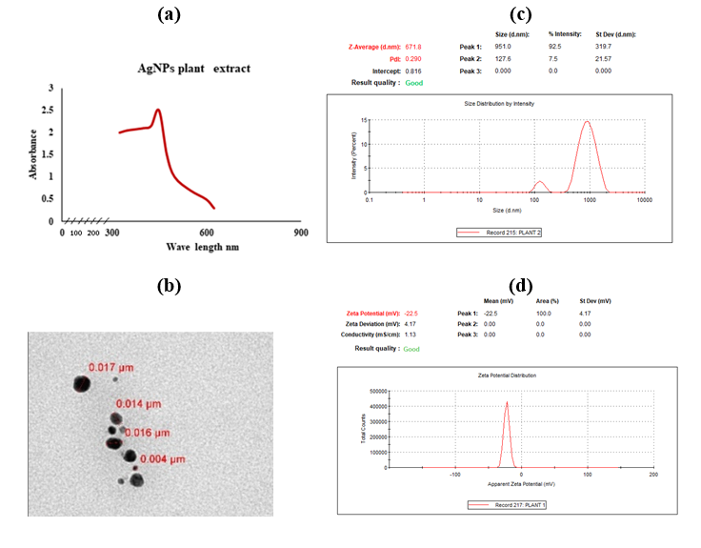

**Figure 2. Characterization of biological synthesized *C. gileadensis* AgNP (a) UV–Vis spectra showing absorbance peak; (b) TEM micrograph; (c) Zetasizer- DLS; (d) Zeta potential distribution- ELS**